著名仲裁院简介
目录
1． 瑞典斯德哥尔摩仲裁院 （AISCC） 2
2． 香港国际仲裁中心 (HKIAC） 2
3． 国际商会仲裁院 （ ICC ） 2
4． 美国仲裁协会 （ AAA ） 2
5． 中国国际经济贸易仲裁委员会 （ CIETAC ） 3
6． 伦敦国际仲裁院 （ LCIA ） 3
7． 解决国际投资争端中心 （ICSID） 3
8． 斯德哥尔摩商会仲裁院（SCC） 4
9． 意大利仲裁协会。（AIA） 4
10． 新加坡国际仲裁中心。(SIAC) 4
11． 世界知识产权组织仲裁与调解中心。（WIPO） 5
12． 孟加拉国际仲裁中心。（BIAC） 5
13． 马来西亚亚洲国际仲裁中心（AIAC） 6
14． 缅甸工商联合会仲裁委员会 6
15． 印度Trinaya Legal律师事务所 7
16． 印度尼西亚国家仲裁委员会（BANI） 8
17． 深圳国际仲裁院。(SCIA） 9
18． 北海国际仲裁院。(BCIA) 9
19． 海南国际仲裁院 10

- 瑞典斯德哥尔摩仲裁院 （AISCC）
The Arbitration Institute of the Stockholm Chamber of Commerce.The Stockholm arbitration court was established in 1917. The Stockholm chamber of commerce is an internal body, but functionally independent. Sweden's status as a neutral country provides a good guarantee for its fairness, and the Stockholm arbitration court enjoys a good international reputation.
瑞典斯德哥尔摩仲裁院成立于1917年。为斯德哥尔摩商会内部机构，但在职能上独立。瑞典中立国的地位，为其公平性提供了很好的保障，瑞典斯德哥尔摩仲裁院享有很好的国际声誉。
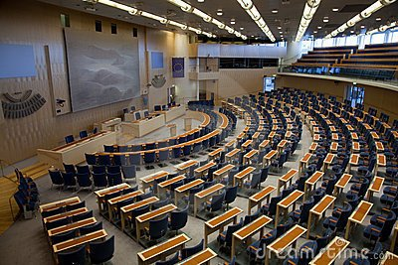

2.香港国际仲裁中心 (HKIAC）
The Hong Kong International Arbitration Center.The Hong Kong international arbitration center was established in 1985 as a private, non-profit company under the Hong Kong companies act. To handle arbitration cases in Hong Kong and international commercial arbitration cases.
香港国际仲裁中心1985年设立，该中心为受限制担保并按香港公司法的规定设立的民间非营利性公司。受理香港区内仲裁案件和国际商事仲裁案件。


3.国际商会仲裁院 （ ICC ）
The International Court of Arbitration of International Chamber of Commerce. Founded in 1923, it is part of the international chamber of commerce. The international chamber of commerce (ICC) was established in Paris, France in 1919, with the purpose of promoting international commercial activities.
其成立于1923年， 属于国际商会的一部分。 国际商会本身于1919年成立于法国巴黎， 其目的是为了促进国际商事活动的进行.它是一个国家间的商会,现有国家会员60多个.其仲裁院的成立也是延续其促进和维护国际商事活动的目的.
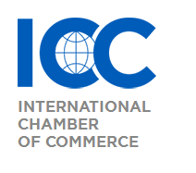

4.美国仲裁协会 （ AAA ）
American Arbitration Association.The American arbitration association is a non-profit public service organization founded in 1926. The arbitration association is headquartered in New York and has branches in several major U.S. states. In recent years, the American arbitration association has set its sights on Europe, where it has set up a branch. The purpose of the American arbitration association is to settle commercial disputes by means of arbitration, mediation, consultation and democratic choice within the scope permitted by law.
美国仲裁协会成立于1926年， 是一个非盈利性的为公众服务的机构。仲裁协会的总部设在纽约，在美国一些主要州设有分部。近年来， 美国仲裁协会又把目光投向欧洲， 并在欧洲设立了分部。美国仲裁协会的目的在于,在法律的许可的范围内,通过仲裁、调解、协商、民主选择等方式解决商事争议。


5.中国国际经济贸易仲裁委员会 （ CIETAC ）
China International Economic and Trade Arbitration Commission.Since 1994, it has become one of the world's leading arbitrators. In terms of the number of international disputes, TTRC has always been in the forefront of the world. While serving as an international commercial arbitration institution, MaoZhong now also accepts all kinds of arbitral disputes of purely domestic nature in China.
从1994 年起， 贸仲已步入世界主要仲裁机构的行列。 在国际争议受案量方面， 贸仲一直排在世界前列。贸仲在作为一个国际商事仲裁机构的同时， 现在也同时受理纯中国国内性质的各类具备仲裁性的纠纷。


6.伦敦国际仲裁院 （ LCIA ）
The London Court of International Arbitration.The London international court of arbitration is the world's oldest arbitration institution, established in 1892. Originally known as the London Chamber of Arbitration, it has been in use since 1903. The London international court of Arbitration is located in London, and its main role in Arbitration cases is to appoint arbitrators and conduct some auxiliary management.
伦敦国际仲裁院是世界上最古老的仲裁机构， 成立于1892年。 原名为： London Chamber of Arbitration， 1903 年起使用现名.伦敦国际仲裁院设在伦敦， 在仲裁案件中其主要作用是指定仲裁员和对案件进行一些辅助性的管理。
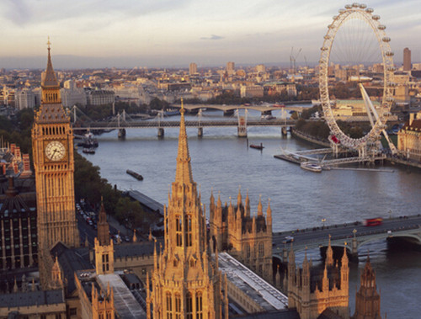

7.解决国际投资争端中心 （ICSID）
The International center for the settlement of investment disputes.The center for the settlement of international investment disputes was established in 1965 under the Washington convention. Headquartered in Washington, dc, is an absolutely international legal entity. The center was established to increase the confidence of investors from developed countries in investing in developing countries and to resolve investment disputes through arbitration and mediation.
解决国际投资争端中心于1965年根据华盛顿公约而成立。总部设在华盛顿特区，是一个绝对地国际性法人组织。 中心设立的目的在于增加发达国家投资者向发展中国家进行投资的信心，并通过仲裁和调解方式来解决投资争议。


8.斯德哥尔摩商会仲裁院（SCC）
The arbitration institute of the stockholm chamber of commerce.The Stockholm chamber of commerce was established in 1917, and its arbitration body was established in 1949. It was established to settle disputes in the fields of industry, trade and transportation. The SCC is headquartered in Stockholm, Sweden, and includes a secretariat and a three-member committee. Three members are appointed by the chamber for three-year terms.
斯德哥尔摩商会成立于1917年，其仲裁机构组织设立于1949年。设立的目的在于解决工业、贸易和运输领域的争议。SCC的总部设在瑞典的斯德哥尔摩，包括秘书局和三名成员组成的委员会。三名委员任期三年，由商会任命。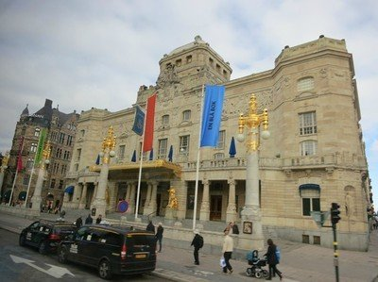

9.意大利仲裁协会。（AIA）
The Italian arbitration association was established in Rome in October 1958 with the support of scholars and representatives of organizations in the industrial and commercial sectors, different economic sectors and the ministry of foreign affairs.
意大利仲裁协会是在学者以及工商业界、不同经济领域的组织和外国事务部的代表支持下，于1958年10月在罗马成立的，其总部设在罗马，下设处理紧急措施常设委员会，在仲裁庭组成之前根据其仲裁规则的规定发布指令。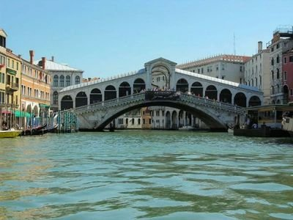

10.新加坡国际仲裁中心。(SIAC)
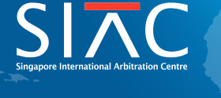
Singapore International Arbitration Centre.the Singapore international arbitration center was established in March 1990 under the proposal of the economic commission of the Singapore government. The center is a guarantee company established under the Singapore companies act to resolve disputes in construction, shipping, banking and insurance, and is committed to developing arbitrators and experts familiar with international arbitration law and practice.
新加坡国际仲裁中心于1990年3月经新加坡政府经济委员会提议成立。该中心是依据新加坡公司法设立的担保公司，以解决建筑工程、航运、银行和保险等方面的争议见长，并致力于培养熟悉国际仲裁法律和实践的仲裁员和专家。

11.世界知识产权组织仲裁与调解中心。（WIPO）
World intellectual property organization is based on the 1967 in Stockholm, Sweden, signed the world convention on intellectual property rights on the creation of the establishment of the government organization, responsible for intellectual property affairs, the headquarters is located in the capital, Geneva, Switzerland, in 1974 to become a specialized agency of the United Nations, is so far the largest international organization. The Wipo arbitration and mediation center, officially established in September 1993 at the plenary session of Wipo, is the international bureau of Wipo and began its work in Geneva in October 1994.

世界知识产权组织是根据1967年在瑞典斯德哥尔摩签署的《关于成立世界知识产权公约》成立的政府组织，负责监管知识产权事务，其总部设在瑞士首都日内瓦，1974年成为联合国的一个专门机构，是迄今为止联合国的最大的国际组织。世界知识产权组织仲裁与调解中心，是1993年9月在世界知识产权组织全体会议上正式获准成立的，属世界知识产权组织的国际局，1994年10月在日内瓦开始工作。

12.孟加拉国际仲裁中心。（BIAC）
Bangladesh International Arbitration Center
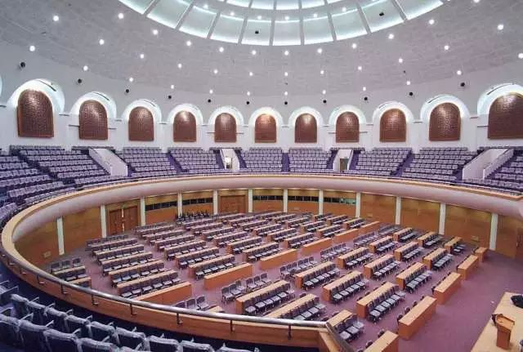
孟加拉国国际仲裁中心成立于2011年4月，是孟加拉国第一个国际仲裁机构，同时也是一个获得政府授权的非盈利性组织。BIAC将提供中立、高效、可靠的商事争端解决服务。2012年4月，BIAC颁布了仲裁准则。
Established in April 2011, the Bangladesh international arbitration center is the first international arbitration institution in Bangladesh and a non-profit organization authorized by the government. BIAC will provide neutral, efficient and reliable commercial dispute resolution services. In April 2012, BIAC promulgated the arbitration rules.

13.马来西亚亚洲国际仲裁中心（AIAC）
Asian International Arbitration Center
founded in 1978 in Kuala Lumpur, Malaysia. The center provides neutral dispute resolution services for trade, business and investment in the Asia-pacific region. Its main functions include promoting the use of international commercial arbitration in the Asia-pacific region, managing domestic and international arbitration in accordance with the revised NCITRAL rules, providing assistance in the enforcement of awards, and providing other ADR methods for dispute resolution.
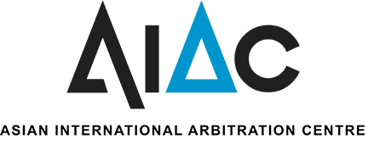
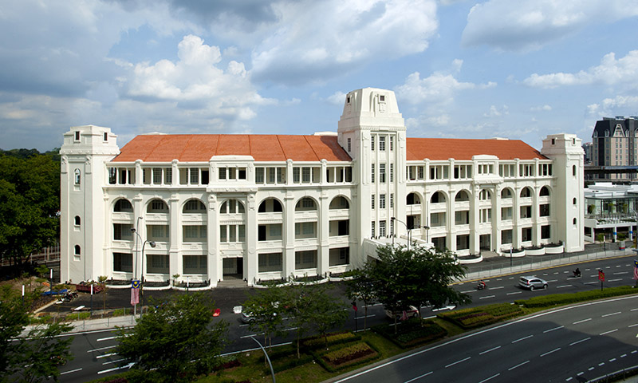
于1978年在马来西亚吉隆坡成立。中心为亚太区域内的贸易、商业以及投资提供中立的争议解决服务，其主要职能如：促进国际商事仲裁在亚太区域的使用、依据经修改的NCITRAL规则管理国内和国际仲裁、在执行裁决上提供协助、提供其他的ADR方式解决争议等。

14.缅甸工商联合会仲裁委员会
The Republic of The Union of Myanmar Federation of Chambers of Commerce and Industry (UMFCCI) and Arbitration Mediation and Conciliation Committee
缅甸工商联合会联合共和国和仲裁、调解和调解委员会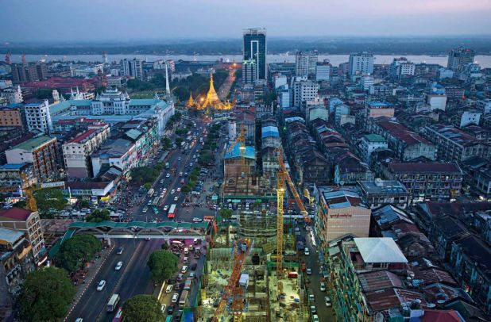

15.印度Trinaya Legal律师事务所
Trinaya Legal 在印度，尼泊尔及巴西为国际客户提供世界级的法律服务，处理复杂的法律法规、不断演变的政策结构和官僚程序。我们拥有一支由100 多名律师组成的紧密团队，具有多部门、跨领域开展实务的能力，专业知识过硬和经验丰富。Trinaya Legal帮助客户制定业务战略和合同，让他们尽量避免和减少争议，同时也拥有着最好的争议解决和诉讼团队。Trinaya Legal 在孟买，班加罗尔，金奈，布巴内斯瓦尔，加德满都，巴西利亚和圣保罗设有办事处。我们有精通普通话的律师，中国执业经理和全职翻译。在印度各地还独立拥有纵向管理的245 名会计师，公司秘书和其他专业人士，以为客户提供端到端服务。
Trinaya Legal provides world-class Legal services to international clients in India, Nepal and Brazil, dealing with complex laws and regulations, evolving policy structures and bureaucratic procedures. We have a close team of more than 100 lawyers, who are capable of carrying out practical work in multiple departments and across different fields with excellent professional knowledge and rich experience. Trinaya Legal helps clients develop business strategies and contracts to minimize and avoid disputes and has the best dispute resolution and litigation teams. Trinaya Legal has offices in mumbai, bangalore, chennai, bhubaneswar, Kathmandu, Brasilia and Sao Paulo. We have mandarin-speaking lawyers, China practice managers and full-time translators. It also has 245 independently managed accountants, corporate secretaries and other professionals across India, providing end-to-end services to clients.

16.印度尼西亚国家仲裁委员会（BANI）
1977年，印度尼西亚国家仲裁委员会，又称“BANI”，在雅加达成立。它是由印尼国家商会资助成立的民间仲裁协会，该会处理国内及国际商事仲裁，并建立了规范诸如仲裁程序及指定仲裁员等问题的仲裁程序规则，它是印尼主要的仲裁协会，并适用诸如国际商会或伦敦仲裁法庭等知名仲裁机构之规则
1977 the national arbitration commission of Indonesia, also known as "BANI", was established in Jakarta. It is funded by the Indonesian national chamber of commerce set up civil arbitration association, should deal with the domestic and international commercial arbitration, and established norms such as arbitration procedure and appoint arbitrators of the arbitration procedure rules, it is the main Indonesian arbitration association, such as the international chamber of commerce or the arbitration tribunal in London and apply the rules of the arbitration institution

17.深圳国际仲裁院。(SCIA）
The international court of arbitration in ShenZhen (also known as "ShenZhen arbitration commission" and "south China international economic and trade arbitration commission," former name "China international economic and trade arbitration commission south China branch", "China international economic and trade arbitration commission (cietac), ShenZhen commission") on December 23, 2018 at home and abroad to release a new list of arbitrators. The new panel of arbitrators will come into operation on 21 February 2019.
深圳国际仲裁院（又称“深圳仲裁委员会”和“华南国际经济贸易仲裁委员会”，曾用名“中国国际经济贸易仲裁委员会华南分会”、“中国国际经济贸易仲裁委员会深圳分会”）于2018年12月23日正式向海内外发布新的仲裁员名册。新的仲裁员名册将于2019年2月21日起启用。

18.北海国际仲裁院。(BCIA)
BEIHAI COURT OF INTERNATIONAL ARBITRATION

Beihai arbitration commission and Beihai international arbitration court (collectively referred to as Beihai Zhong), established by Beihai municipal people's government in January 2003, are civil and commercial arbitration institutions that independently, fairly, efficiently and professionally settle contract disputes and other disputes over property rights and interests between natural persons, legal persons and other organizations as equal subjects. In August 2017, with the approval of the judicial department of Guangxi Zhuang autonomous region, Beihai international arbitration court was added to the north sea arbitration commission, and the seal of Beihai international arbitration court can be used at the same time.北海仲裁委员会、北海国际仲裁院（统称北仲）由北海市人民政府组建，成立于2003年1月，是独立、公正、高效、专业地解决平等主体自然人、法人和其他组织之间发生的合同纠纷和其他财产权益纠纷的民商事仲裁机构。2017年8月，经广西壮族自治区司法厅批准，北海仲裁委员会同时增挂北海国际仲裁院，并可同时使用北海国际仲裁院的印章。

19.海南国际仲裁院

海南仲裁委员会（海仲）由海南省人民政府依法于1996年5月21日组建，是海南省内唯一民商事仲裁机构，会址设在海口市。2011年10月21日，经海南省人民政府批准，由海口仲裁委员会更名为海南仲裁委员会。2018年7月，经海南省人民政府批准更名为海南国际仲裁院（海南仲裁委员会）。鉴于海南省直管市县的行政体制和海南经济大特区、国际旅游岛等独有特色，国务院在审批仲裁机构设置时将海仲定为除直辖市外唯一的省级区域仲裁机构。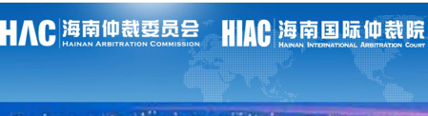

Hainan arbitration commission (haizhong) was established by the people's government of hainan province on May 21, 1996. Approved by hainan provincial people's government, haikou arbitration commission was renamed as hainan arbitration commission on October 21, 2011. In July 2018, it was renamed as hainan international arbitration academy (hainan arbitration commission) with the approval of hainan provincial people's government. In view of the administrative system of hainan province directly in charge of cities and counties and the unique characteristics of hainan special economic zone and international tourism island, the state council has designated haizhong as the only provincial regional arbitration institution except for the municipality directly under the central government when examining and approving the establishment of arbitration institutions.

